Krabi Trip
Mode of Transportation - The cheapest way to get from Krabi Town to Ao Nang or from Ao Nang to Krabi Town is with the Songthaew, the red shared taxis. The ride on these costs 50 baht per person and takes about 30 minutes
1st Day July 27th (Wednesday)
Time of Arrival 12:15pm
Krabi Town
Head over to Hotel
Choices Near Krabi River
1. Krabi Riverview Hotel - already paid
Price: PHP 1,867.30/2 = Php933.65 or Php933.00 each or SGD24
Check-in 2:00pm Manila time
Check out 12:00nn
1:30pm – 2:30pm Lunch at Chalita Café & Restaurant, Chao Fah Road
Timings: 10AM–12MN
3:00pm Explore Krabi River and Wat Kaew Korawaram
5:00pm Khao Khanab Nam, Caves
1 or 2 hour boat trip for 500 / 800 baht. Sail over the river and through the mangrove where you go looking for monkeys. You will also visit the impressive Kanab Nam Cave (30 baht) where old rock paintings can be seen. If you book the long trip you will pass a fishing village with a fish farm and a fish restaurant where you can eat fresh fish. Part of this trip can also be done by kayak. We can book the mangrove trip on the spot on the promenade near the Mud Crab sculpture.
8:00pm Dinner at River Restaurant near hotel or Poo Dam Night Market open Monday to Wednesday from 5 – 10 PM
2nd Day July 28 (Thursday)
Ao Nang Hotels from July 28-August01
Pakasai Resort - ₱ 8,355.45/2 = Php4,178 each or SGD105 each
Go to the next hotel at 9am
11:00am Early Lunch at 888 near Pakasai
776.89 baht
2486 kayaking at night
1864.42 rock climbing, cave connection and rapelling
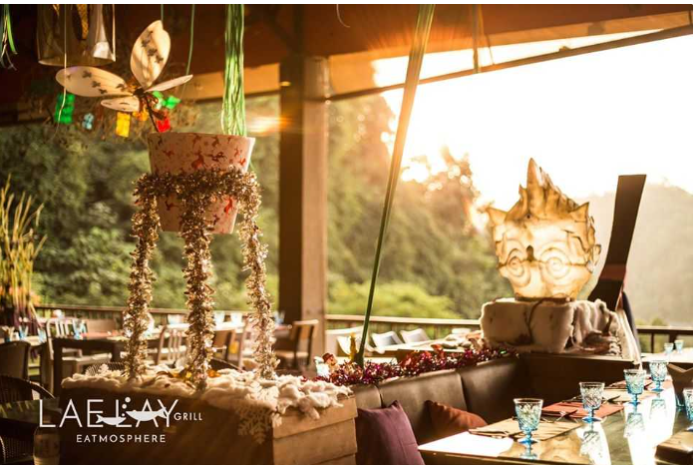
1:00pm 7 islands tour snorkeling, sunset and bbq
Php4,918/2 = Php2,459 each or SGD61 each
Islands:
Koh Yawasam
Koh Kai
Koh Tub
Chicken and Mor Islands
Koh Tan Ming
Koh Poda
Koe Raeng – bio luminescent plankton
Dinner: Lae Lay Grill, Ao Nang - for seafood lovers. Located on a hill, the restaurant has a lovely set up and it overlooks the Nopparat Thara Beach
Timings: 11AM–10PM
3rd Day July 29 (Friday)
Breakfast at 7:00am Chao Lay
Krabi to Phi Phi Day Tour by Speedboat
Php5,056/2 = Php2,528 each or SGD63
Islands:
Maya Bay
Viking Cave/Monkey Beach
Koh Phi Phi Don
Bamboo Island
Lunch at Patcharee Bakery in Phi Phi Island
We left for Koh Phi Phi Don and head over to Railay,did not go to Bamboo Island
Dinner: Kodam near Pakasai
4th Day July 30 (Saturday)
Full Day Tiger Cave Temple, Emerald Pool & Hot Springs
Price: Php2984/2 = Php1492/each or SGD38
Night Kayaking
Dinner and Drinks: No dinner
5th day July 31 (Sunday)
Breakfast – Café 8.98 near Ao Nang Beach
8:00am Krabi: Ao Nang Elephant Sanctuary Half-Day Tour
Php3,611 only Niskie
Head over to Railay and do rock climbing
Late lunch at Railay beach
7:00pm: Carnivore Steak and Grill near Pakasai
8:00pm – Massage Corner for body scrub and Thai massage
6th Day August 01 (Monday)
Early Lunch at Coffee Club in Ao Nang Beach
Yi Tzeng’s Payment to Niskie = SGD291

